Samuel Rivers

September 14, 2020

BUS 310-009

Week #3: Chapter #3 In-Class Activities Homework

Page #143 3.1, 3.7, and 3.8 activities

3.1 a/b.

|  |  |
| --- | --- |
| Mean | 6 |
| Standard Error | 1.30384048 |
| Median | 7 |
| Mode | #N/A |
| Standard Deviation | 2.91547595 |
| Sample Variance | 8.5 |
| Kurtosis | -1.5986159 |
| Skewness | -0.6052891 |
| Range | 7 |
| Minimum | 2 |
| Maximum | 9 |
| Sum | 30 |
| Count | 5 |

Coefficient of Variation: 6.8

c. Z = (Data Value – Sample Mean) / Sample Deviation

|  |  |
| --- | --- |
| Value | Z-Score |
| 7 | 0.34299717 |
| 4 | -0.6859943 |
| 9 | 1.02899151 |
| 8 | 0.68599434 |
| 2 | -1.3719887 |

No Outliers

d. The mean is less than the median, therefore the distribution is left-skewed

3.7 a. That means that are an equal number of new houses under $323,100 and over $370,800.

b. This means that the average sales price of new houses was $370,800.

c. Because the mean sales price is greater than the median sales price, the distribution is right-skewed.

3.8 a/b.

Download Speed:

|  |  |
| --- | --- |
| Mean | 14.2333333 |
| Standard Error | 2.35218574 |
| Median | 11.2 |
| Mode | #N/A |
| Standard Deviation | 7.05655723 |
| Sample Variance | 49.795 |
| Kurtosis | -1.5292432 |
| Skewness | 0.1931943 |
| Range | 19.5 |
| Minimum | 4.5 |
| Maximum | 24 |
| Sum | 128.1 |
| Count | 9 |

Coefficient of Variance: 44.2622222

Upload Speed:

|  |  |
| --- | --- |
| Mean | 8.12222222 |
| Standard Error | 1.34296291 |
| Median | 6.4 |
| Mode | #N/A |
| Standard Deviation | 4.02888874 |
| Sample Variance | 16.2319444 |
| Kurtosis | -1.2358367 |
| Skewness | 0.38615366 |
| Range | 11.3 |
| Minimum | 3 |
| Maximum | 14.3 |
| Sum | 73.1 |
| Count | 9 |

Coefficient of Variance: 14.4283951

c. Yes it is skewed to the right because the mean is greater than the median.

d. Overall, the average download speed is comparatively faster than the average upload speed.

Activity 3.16 page 144

a/b.

|  |  |
| --- | --- |
| Mean | 7.11466667 |
| Standard Error | 0.53761897 |
| Median | 6.68 |
| Mode | #N/A |
| Standard Deviation | 2.08218932 |
| Sample Variance | 4.33551238 |
| Kurtosis | -1.0562739 |
| Skewness | 0.07249306 |
| Range | 6.67 |
| Minimum | 3.82 |
| Maximum | 10.49 |
| Sum | 106.72 |
| Count | 15 |

Coefficient of Variance: 4.04647822

Z-Scores:

|  |  |
| --- | --- |
| 9.66 | 1.222431 |
| 5.90 | -0.58336 |
| 8.02 | 0.434799 |
| 5.79 | -0.63619 |
| 8.73 | 0.775786 |
| 3.82 | -1.58231 |
| 8.01 | 0.429996 |
| 8.35 | 0.593286 |
| 10.49 | 1.62105 |
| 6.68 | -0.20875 |
| 5.64 | -0.70823 |
| 4.08 | -1.45744 |
| 6.17 | -0.45369 |
| 9.91 | 1.342497 |
| 5.47 | -0.78987 |

No outliers

c. Yes data is skewed to the right because the mean is greater than the median.

d. No his statement is not accurate. It will likely take an average of 7 minutes.

Activity 3.25 page 151

a.

|  |  |
| --- | --- |
| First Quartile | 14 |
| Third Quartile | 24 |
| Interquatile Range | 10 |

b.

|  |  |
| --- | --- |
| First Quartile | 14 |
| Third Quartile | 21 |
| Min | 5 |
| Max | 41 |
| Median | 18 |

c. 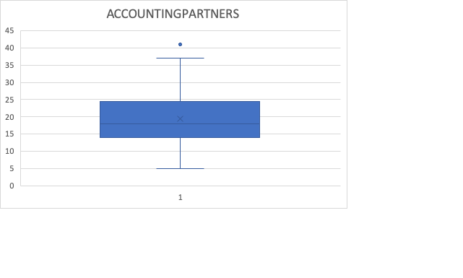

The shape is slightly toward the bottom section of the range.

Activity 3.33 page 155

a.

|  |  |
| --- | --- |
| Mean | 276.490196 |
| Standard Error | 39.1174739 |
| Median | 214 |
| Mode | 31 |
| Standard Deviation | 279.35464 |
| Sample Variance | 78039.0149 |
| Kurtosis | 4.56127612 |
| Skewness | 2.00739486 |
| Range | 1275 |
| Minimum | 25 |
| Maximum | 1300 |
| Sum | 14101 |
| Count | 51 |

b. 0%

c. Yes the results in b are far lower than expected.

Activity 3.38 page 160

a. X Covariance: 21.4

Y Covariance: 192.09

b. X Coefficient of Correlation: 1

Y Coefficient of Correlation: 1

c. The relationship between x and y is very strong because they share the same coefficient of correlation.